Liberia

## GNI per capita and development level

The data set shows the GNI per capita and development level of the country each year.

## # A tibble: 19 x 5  
## country iso3c date GNIperCapita devCategory   
## <chr> <chr> <dbl> <dbl> <chr>   
## 1 Liberia LBR 1996 3685. Lower Middle Income  
## 2 Liberia LBR 1998 4881. Upper Middle Income  
## 3 Liberia LBR 2000 554. Low Income   
## 4 Liberia LBR 2002 530. Low Income   
## 5 Liberia LBR 2003 358. Low Income   
## 6 Liberia LBR 2004 399. Low Income   
## 7 Liberia LBR 2005 408. Low Income   
## 8 Liberia LBR 2006 425. Low Income   
## 9 Liberia LBR 2007 453. Low Income   
## 10 Liberia LBR 2008 466. Low Income   
## 11 Liberia LBR 2009 460. Low Income   
## 12 Liberia LBR 2010 467. Low Income   
## 13 Liberia LBR 2011 502. Low Income   
## 14 Liberia LBR 2012 508. Low Income   
## 15 Liberia LBR 2013 538. Low Income   
## 16 Liberia LBR 2014 528. Low Income   
## 17 Liberia LBR 2015 521. Low Income   
## 18 Liberia LBR 2016 500. Low Income   
## 19 Liberia LBR 2017 497. Low Income

## GDP growth and economic growth classification

The data set shows the GDP growth and the ecomic growth classification of the country each year.

## # A tibble: 19 x 5  
## country iso3c date GDPannualGrowthRate GDPgrowthCategory4  
## <chr> <chr> <dbl> <dbl> <fct>   
## 1 Liberia LBR 1996 3.05 moderate growth   
## 2 Liberia LBR 1998 6.18 fast growth   
## 3 Liberia LBR 2000 2.48 slow growth   
## 4 Liberia LBR 2002 3.76 moderate growth   
## 5 Liberia LBR 2003 -30.1 negative grwoth   
## 6 Liberia LBR 2004 2.62 moderate growth   
## 7 Liberia LBR 2005 5.28 moderate growth   
## 8 Liberia LBR 2006 8.04 fast growth   
## 9 Liberia LBR 2007 9.54 fast growth   
## 10 Liberia LBR 2008 7.15 fast growth   
## 11 Liberia LBR 2009 5.30 moderate growth   
## 12 Liberia LBR 2010 6.10 fast growth   
## 13 Liberia LBR 2011 8.20 fast growth   
## 14 Liberia LBR 2012 7.99 fast growth   
## 15 Liberia LBR 2013 8.70 fast growth   
## 16 Liberia LBR 2014 0.701 slow growth   
## 17 Liberia LBR 2015 0 negative grwoth   
## 18 Liberia LBR 2016 -1.60 negative grwoth   
## 19 Liberia LBR 2017 2.47 slow growth

## Development trend

The plot shows the development trend of the country.

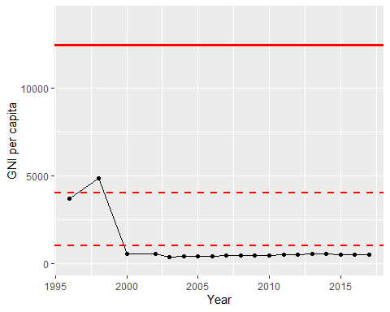

GNI Per Capita Trend